**Brief tutorial for Miedema Calculator**

We may suggest the potential users to read the following tutorial. The latest software, additional information and tutorials can be found on our website: <https://sites.google.com/site/miedemacalc/> or <http://miedemacalc.weebly.com>. We now present only the five major functional module interfaces.

S.1. Formation enthalpies of binary intermetallic compounds

Fig. S1 presents the module interface for formation enthalpies of binary intermetallic compounds. The original Miedema’s model and two improved ones are supported in this module. One may refer to the following procedure for the calculation of formation enthalpies of binary intermetallic compounds based on the original Miedema’s model and two improved ones:

1. Launch the Miedema calculator by double click the software,
2. In menu, choose “Module”-> “Formation enthalpy of compound” to launch the module interface (see Fig. S1);
3. Choose the alloy system A-B from the drop list;
4. Choose or input the alloy composition;
5. Choose the database “Mied89” or “ZSL07”, the default is “Mied89”.
6. Click the “Disp_Para” button, you will get the model parameters shown in the region “Model parameters used”;
7. Click the “Perf_Calc” button, it will perform self-consistent calculation for formation enthalpies, and the calculated results will be shown in the region “Calculated Results”.

S.2. Formation enthalpies of ternary intermetallic compounds

Fig. S2 presents the module interface for the formation enthalpies of ternary intermetallic compounds. The original Miedema’s model and several geometrical models are supported in this module. One may refer to the following procedure for the calculation of formation enthalpies of ternary intermetallic compounds based on the various geometrical models:

1. Launch the Miedema calculator by double click the software;
2. In menu, choose “Module”-> “Formation enthalpy of ternary compound” to launch the module interface (see Fig. S2);
3. Choose the ternary alloy system A-B-C from the drop list;
4. Choose or input the alloy composition for each element;
5. Choose the binary model for the calculation of formation enthalpies of binary counterparts: “Mied89” or “ZRF14”, the default is “Mied89”.
6. Click the “Disp_Para” button, you will get the model parameters shown in the region “Model parameters used”;
7. Click the “Perf_Calc” button, it will perform self-consistent calculation for formation enthalpies, and the calculated results will be shown in the region “Calculated Results”.

S.3. Formation enthalpies of concentrated statistical solid solutions

Fig. S3 presents the module interface for the formation enthalpies of concentrated statistical solid solutions. The chemical enthalpies, elastic mismatch enthalpies and structural enthalpies based on Miedema’s method and Alonso’s method are supported in this module. For the calculation of formation enthalpies of binary concentrated statistical solid solutions:

1. Launch the Miedema calculator by double click the software;
2. In menu, choose “Module”-> “Formation enthalpy of solid solution” to launch the module interface (see Fig. S3);
3. Choose the ternary alloy system A-B-C from the drop list;
4. Choose or input the alloy composition for each element;
5. Click the “Disp_Para” button, you will get the model parameters shown in the region “Model parameters used”;
6. Click the “Perf_Calc” button, it will perform self-consistent calculation for formation enthalpies, and the calculated results will be shown in the region “Calculated Results”.

S.4. Formation enthalpies of binary amorphous alloys

One may refer to the following procedure for the calculation of formation enthalpies of binary amorphous alloys based on the Miedema’s method and Alonso’s method:

1. Launch the Miedema calculator by double click the software;
2. In menu, choose “Module”-> “Formation enthalpy of amorphous alloy” to launch the module interface (see Fig. S4);
3. Choose the binary alloy system A-B from the drop list;
4. Choose or input the alloy composition for each element;
5. Click the “Disp_Para” button, you will get the model parameters shown in the region “Model parameters used”;
6. Click the “Perf_Calc” button, it will perform self-consistent calculation for formation enthalpies, and the calculated results will be shown in the region “Calculated Results”.

S.5. Volume corrections of solid solutions and compounds upon alloying

One may refer to the following procedure for the calculation of the volume corrections of solid solutions and compounds upon alloying:

1. Launch the Miedema calculator by double click the software;
2. In menu, choose “Module” -> “Volume correction in alloying” to launch the module interface (see Fig. S5);
3. Choose the binary alloy system A-B from the drop list;
4. Choose or input the alloy composition for each element;
5. Click the “Disp_Para” button, you will get the model parameters shown in the region “Model parameters used”;
6. Click the “Perf_Calc” button, it will perform self-consistent calculation for formation enthalpies, and the calculated results will be shown in the region “Calculated Results”.

S.6. Input mode

One may refer to the following procedure for the calculation of formation enthalpy of binary hybrids of transition metals (or other binary alloys) in “input mode”:

1. Steps 1)-6) is the same to those of S.1 for the calculation of formation enthalpy of binary compounds;
2. In menu, choose “Control”-> “Input mode” to make the model parameters editable in the region “Model parameters used”;
3. Input or modify the values in the region “Model parameters used”;
4. Click the “Perf_Calc” button, it will perform self-consistent calculation based on the parameters input or is modified, and the calculated results will be shown in the region “Calculated Results”.

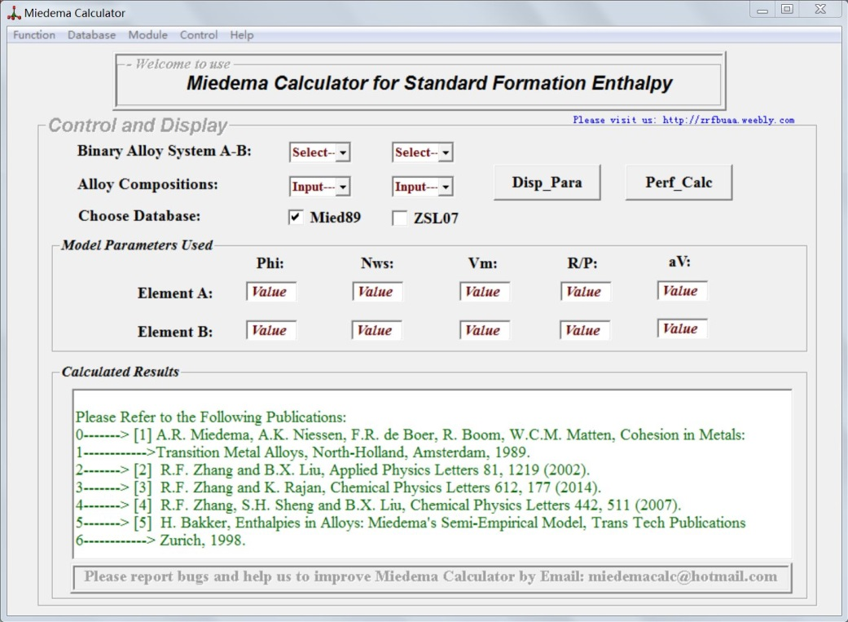

**Fig. S1.** The module interface for the formation enthalpies of binary intermetallic compounds.

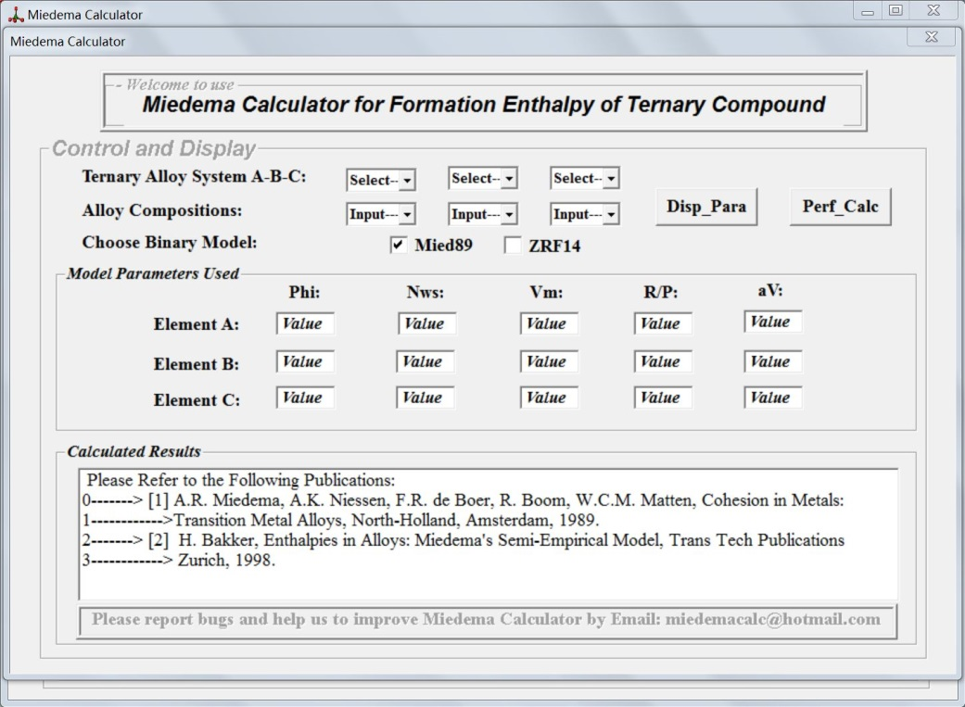

**Fig. S2.** The module interface for the formation enthalpies of ternary intermetallic compounds.

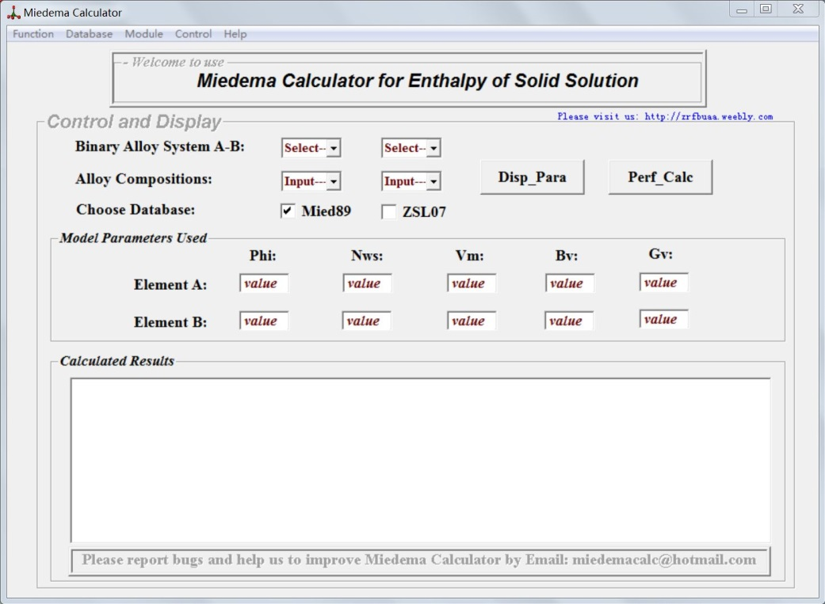

**Fig. S3.** The module interface for the formation enthalpies of binary concentrated statistical solid solutions.

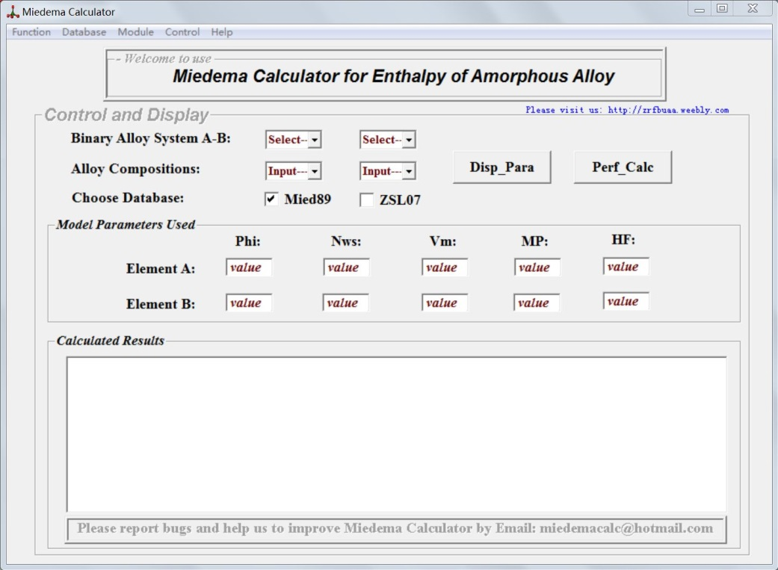

**Fig. S4.** The module interface for the formation enthalpies of binary amorphous alloys.

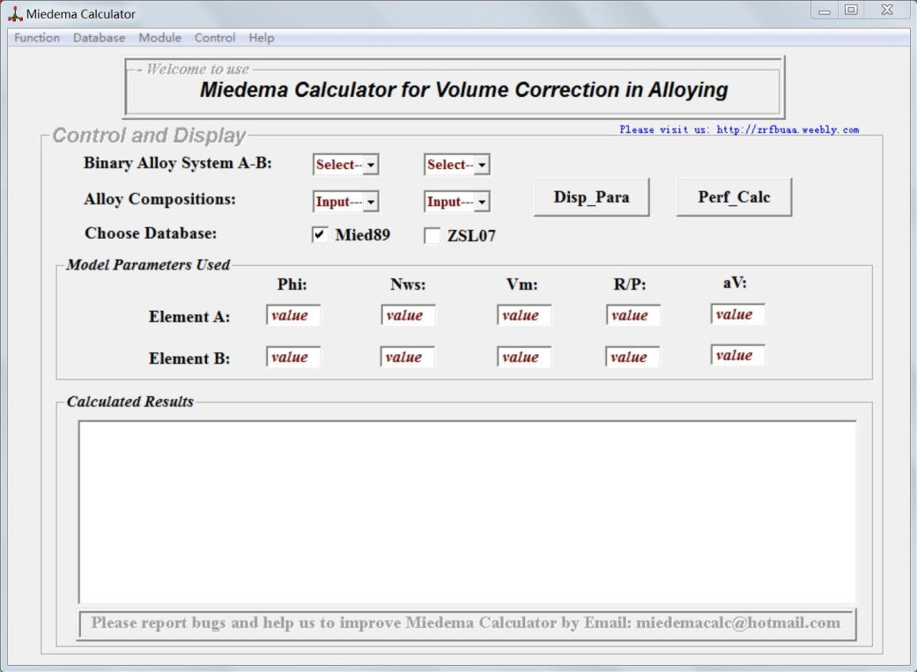

**Fig. S5.** The module interface for the volume corrections of solid solutions and compounds upon alloying.